Session 12 — Problem A: DMA mem-to-mem (HAL, rung 0_1)
STM32F103C8T6 · bare-metal · IAR EWARM 8.3 · verified on board

Table of Contents

1. Introduction
DMA (Direct Memory Access) is a hardware engine inside the microcontroller that moves data between memory and peripherals (or memory and memory) on its own, without the CPU executing a single instruction of the copy. The program declares the transfer up front — source address, destination address, element count, element size — then presses an enable bit; from that moment the DMA controller arbitrates the bus and performs every read/write itself. It is best pictured as a conveyor belt: set it up once, switch it on, and the goods move while the operator stands aside.
Why DMA must exist. Without it, every byte a peripheral produces or consumes costs CPU time: either the CPU spins in a polling loop asking "ready yet?", or it takes an
interrupt per data item — hundreds of context switches just to shovel a buffer. Both approaches burn cycles, add latency jitter, and scale badly: a 1 Mbps UART stream alone can saturate a small core. DMA removes the CPU from the data path entirely, so the core is free to compute (or sleep, saving power) while transfers proceed at bus speed with deterministic timing.
Real-world applications today. DMA is the backbone of virtually every data-moving subsystem in modern embedded devices:
- Audio — I2S/SAI streams feed DACs/codecs from circular DMA buffers (headphones, TWS earbuds, smart speakers).
- Analog acquisition — ADCs sample continuously into RAM ring buffers (motor control, battery monitors, biomedical sensors).
- Communications — UART/SPI/I2C/Ethernet/USB controllers exchange whole frames without per-byte interrupts.
- Displays and cameras — frame buffers are refreshed and captured by dedicated DMA paths (LTDC, DCMI).
- Storage — SD-card and flash controllers stream sectors via DMA.
On the STM32F103 used here, the DMA1 controller offers 7 channels shared by these peripheral classes. This report studies it in its purest form — a memory-to-memory copy — where the concept is easiest to see and verify.
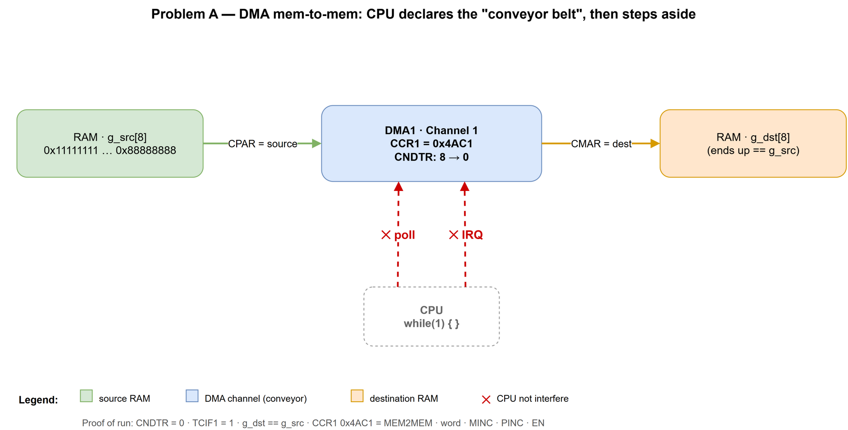
Figure 1. The DMA concept on Problem A's datapath: RAM g_src → DMA1 Channel 1 → RAM g_dst at bus speed; the CPU sits idle in while(1) and its usual poll / IRQ involvement is crossed out — it does not interfere with the transfer

2. Problem Identification
Through Sessions 1–11 of this project, every peripheral was driven the CPU-centric way: the core either polled status flags or serviced interrupts, and *all* data passed through CPU registers. DMA introduces a third actor on the bus — and with it a new mental model (declare-then-delegate) and a new debugging surface (channel registers instead of program flow). That gap is what this session closes.
The learning problem is deliberately framed at the register level, not the library level: a HAL call that "just works" teaches nothing about *what was written where*. The project's standing goal — no vendor lock-in, understanding down to the bit — demands that any library usage be verifiable against the raw registers underneath.
Problem A (this report): use DMA1 Channel 1 to copy 8 words (32 bytes) RAM→RAM, with the CPU parked in an empty while(1) — no polling, no interrupts (the "Stage 0" rule). Small enough to verify exhaustively, complete enough to exercise the whole DMA programming model (CCR/CNDTR/CPAR/CMAR/ISR).
Problem A spans three stages — the same problem re-implemented at three API layers:
Stage | API layer | Status
0_1 | HAL (vendor library) | PASS on board — this report
0_2 | CMSIS (register names) | next
0_3 | raw registers (project DSL per STANDARD.md) | planned

Problem B — the timer-paced sibling problem of Session 12 — has its own report; the two share only the session map (section 4.1) and the acceptance method.

3. Objective
Acceptance criteria set before writing any code:
- Build: iarbuild on config DMA_B12_S01_HAL completes with 0 errors, 0 warnings.
- Function: after one run on real hardware, g_dst == g_src for all 8 words.
- Proof of completion in registers: DMA1_ISR.TCIF1 = 1 and DMA1_CNDTR1 = 0.
- Stage-0 rule respected: no polling loop, no interrupt enabled (TCIE/HTIE/TEIE = 0); the CPU contributes nothing after EN = 1.
- Minimal vendor footprint: compile only the HAL modules strictly required (target: 1 of ≈30), so later stages can drop HAL without rework.
- Evidence captured, not recalled: C-SPY register dumps and Live Watch logs saved to Problem_A/logs/, screenshots to Problem_A/assets/.
- Fingerprint recorded for reuse: the register set {CCR, CNDTR, CPAR, CMAR, ISR} becomes the reference that stages 0_2 and 0_3 must reproduce exactly.

4. Methodology and Progress

4.1 Method — one problem, three API rungs, one fingerprint
The core method of Session 12 is a priority ladder: solve the identical problem at
HAL (rung 0_1, simplest), then CMSIS (rung 0_2, readable register names), then
raw registers (rung 0_3, project DSL). Acceptance is a diff of register fingerprints: if all three implementations leave the same values in
CCR/CNDTR/CPAR/CMAR, they are provably the same thing at the hardware level — the library was only ever a way of *typing*, not a source of behavior.
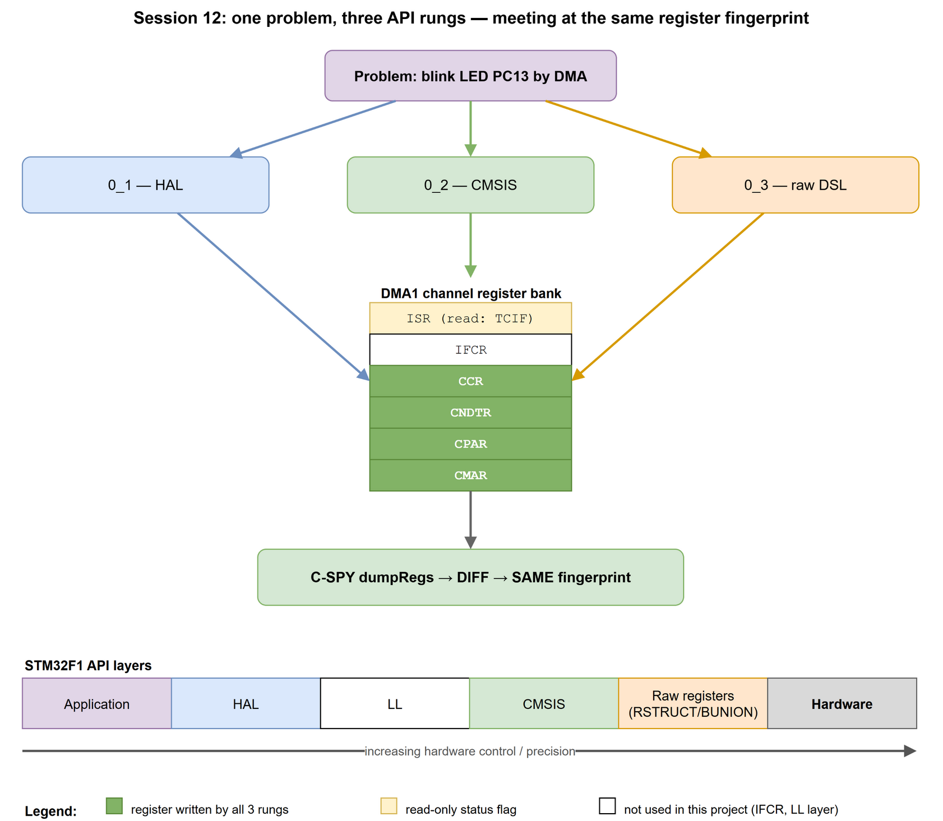
Figure 2. The Session 12 API ladder: the application descends through HAL / CMSIS / raw registers to the hardware; the register bank on the left shows exactly which DMA registers this problem touches (green = written, yellow = read); the arrow marks increasing hardware control and precision
Problem A's architecture — the one datapath all three stages must reproduce:
Problem A architecture (shared by stages 0_1 / 0_2 / 0_3)

g_src[8] @ 0x20000000 g_dst[8] @ 0x20000064
+----------------+ DMA1 Channel 1 +----------------+
| RAM (source) | ========================> | RAM (dest) |
+----------------+ MEM2MEM=1, 32-bit word +----------------+
MINC=1, PINC=1, N=8
one-shot (CIRC=0)

CPU: while(1) { } -- no polling, no interrupts (Stage-0 rule)
This report covers the (Problem A · rung 0_1 HAL) cell of the session map below; green cells are already verified on the board.
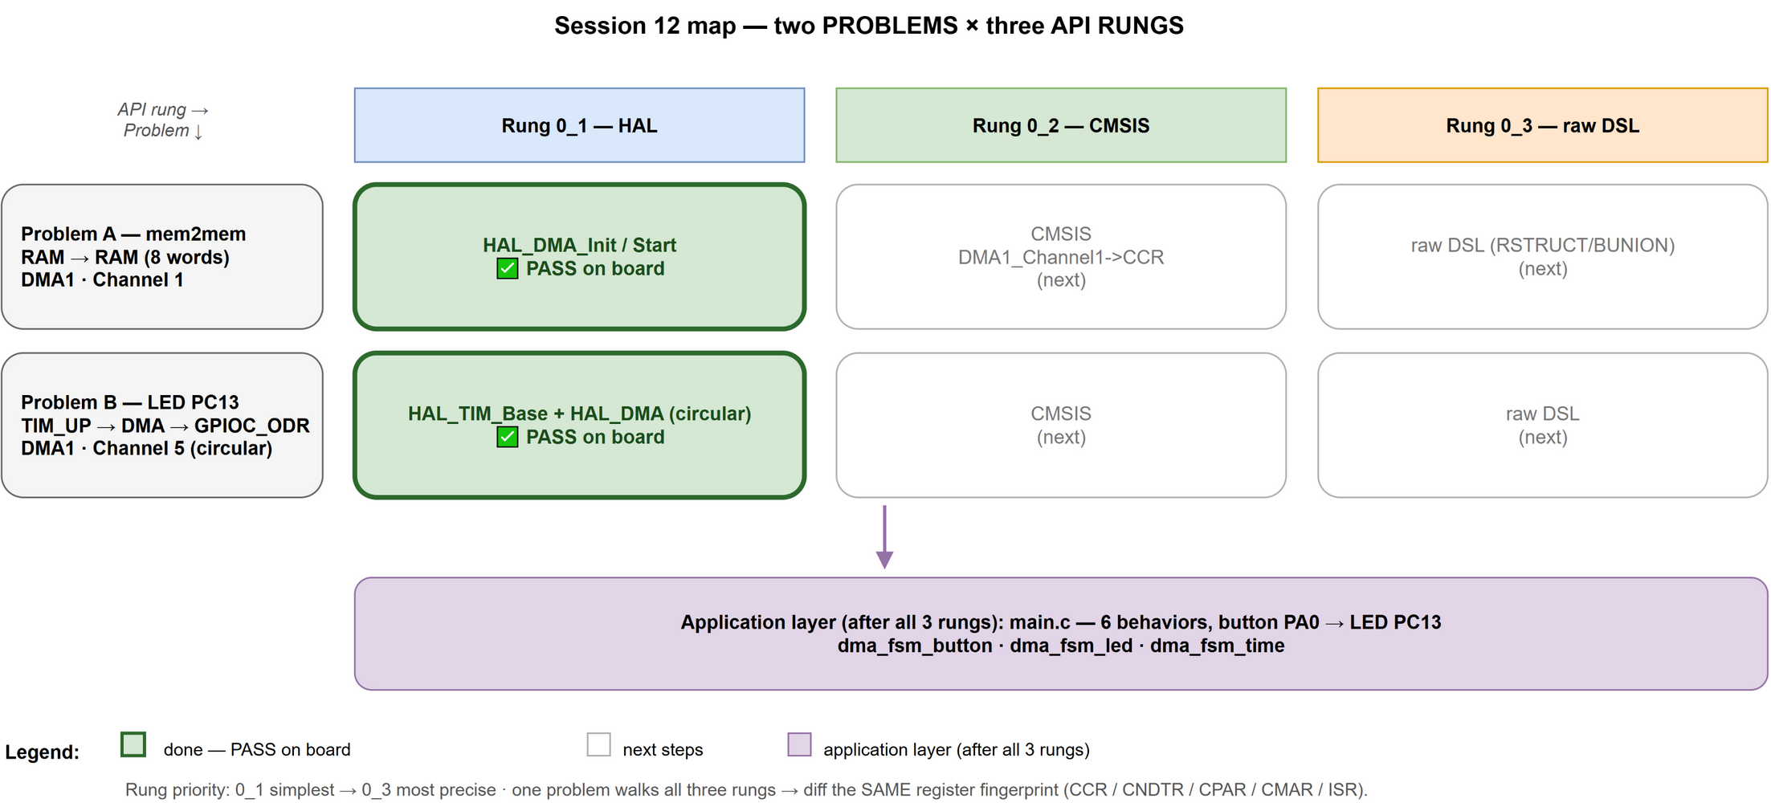
Figure 3. The Session 12 map: two problems × three API rungs; green cells = PASS on board; this report covers the (Problem A · HAL) cell

4.2 Toolchain and build profiles
Hardware: STM32F103C8T6 (Blue Pill), flashed and debugged over ST-Link V2, pure SWD, inspected with C-SPY (IAR EWARM 8.3). The project keeps one source list and splits it per build profile with <excluded> flags; each profile enables only its own defines. Rung 0_1 gets a dedicated profile `DMA_B12_S01_HAL` (STM32F103xB +
USE_HAL_DRIVER): the compile list is just main_buoi12_dma.c + stm32f1xx_hal_dma.c + startup + cortex_m3.c, every legacy LL / smoke-test file excluded — so the old LL
Debug build stays untouched. Notably, hal.c / system_stm32f1xx.c are not needed (startup does not call SystemInit; the linker discards unused HAL code).
The build↔board loop at the right of the figure is the project's hardware boundary: the AI owns "does it BUILD" (iarbuild CLI), the user owns "does it WORK" (on-board run); hardware truth crosses back only as captured logs.
Adding / removing a flag (define). In the IAR GUI: *Project → Options… → C/C++ Compiler → Preprocessor → Defined symbols* — one symbol per line, set per configuration (select the profile in the workspace drop-down first). Adding a line defines the flag for that profile only; deleting the line removes it. The same list is stored per configuration as the <CCDefines> option inside test.ewp, which is why a profile's flag changes show up as reviewable diffs in git.
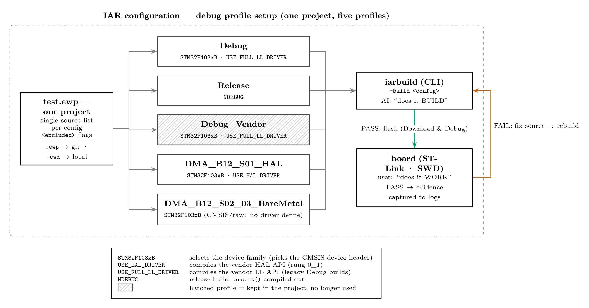
Figure 4. IAR configuration — debug profile setup: one project fans out to five build profiles (only the enabled flags differ; the legend decodes each flag); the hatched profile (Debug_Vendor) is kept in the project but no longer used; all profiles feed iarbuild — PASS flashes to the board, FAIL loops back to fix-and-rebuild

4.3 Implementation (evidence in code)
A single main.c serves all stages; the rung is selected with #ifdef STAGE_0_x labels (the label is a *macro name*, not a number — it must be tested with #ifdef, never
#if ==). The complete Stage 0_1 core:
static void Stage01_MemToMem(uint32_t *src, uint32_t *dst)
{
__HAL_RCC_DMA1_CLK_ENABLE(); /* DMA1 clock on */
hdma.Instance = DMA1_Channel1;
hdma.Init.Direction = DMA_MEMORY_TO_MEMORY;
hdma.Init.PeriphInc = DMA_PINC_ENABLE; /* source auto-increment */
hdma.Init.MemInc = DMA_MINC_ENABLE; /* dest auto-increment */
hdma.Init.PeriphDataAlignment = DMA_PDATAALIGN_WORD;/* 32-bit */
hdma.Init.MemDataAlignment = DMA_MDATAALIGN_WORD;
hdma.Init.Mode = DMA_NORMAL; /* one-shot */
hdma.Init.Priority = DMA_PRIORITY_LOW;
HAL_DMA_Init(&hdma);
HAL_DMA_Start(&hdma, (uint32_t)src, (uint32_t)dst, 8u); /* fire */
/* NO polling, NO interrupts: read g_dst + CNDTR in C-SPY */
}
Two HAL calls and one clock macro — that is the entire vendor surface of rung 0_1. Everything after HAL_DMA_Start() happens in silicon.

4.4 Verification method
- Flash via ST-Link, run through Stage01_MemToMem(), halt.
- Register fingerprint: read DMA1 Channel 1 in the C-SPY Registers window with every
bit-field expanded; dump to Problem_A/logs/DMA1.log.
- Memory check: compare g_src[] / g_dst[] in Live Watch (decimal and hex);
logs LiveWatch-binary.log / LiveWatch-hexa.log.
- Keep the fingerprint as the acceptance reference for stages 0_2 / 0_3.

4.5 Progress
Step | Outcome
Write main_buoi12_dma.c (STAGE_0_1) | done
Wire test.ewp profile DMA_B12_S01_HAL | done — old configs untouched
Build #1 | FAIL — 3× Pe014 from #if STAGE == 0_1 (integer-only #if)
Fix: #ifdef STAGE_0_1 labels | done — recorded in bug_log
Build #2 | 0 errors, 0 warnings
On-board run + capture | PASS — evidence in Problem_A/logs/ and assets/
Stage 0_2 (CMSIS), 0_3 (raw DSL) | not started — next sessions

5. Result and Evaluation

5.1 Register fingerprint — DMA1 · Channel 1
In every screenshot below, red boxes mark live/changing values (the proof the transfer ran) and blue boxes mark configuration/fingerprint values (the proof it was set up as coded).
Table 1 — channel-1 registers after the run:
Register | Value | Meaning
DMA1_ISR | 0x00000007 | GIF1+TCIF1+HTIF1 → TCIF1 = 1 (transfer complete)
DMA1_CCR1 | 0x00004AC1 | channel configuration (decoded in Table 2)
DMA1_CNDTR1 | 0x00000000 | 0 words remaining → all 8 transferred
DMA1_CPAR1 | 0x20000000 | source = &g_src[0]
DMA1_CMAR1 | 0x20000064 | destination = &g_dst[0]

Table 2 — decoding CCR1 = 0x00004AC1 (bit-fields read directly from C-SPY):
Bit-field | Value | Meaning
MEM2MEM | 1 | memory→memory copy
MSIZE / PSIZE | 0b10 / 0b10 | 32-bit (word) elements on both sides
MINC / PINC | 1 / 1 | both addresses auto-increment
CIRC | 0 | one-shot
TCIE / HTIE / TEIE | 0 | all interrupts off (per the Stage 0 rule)
EN | 1 | channel enabled

→ a 100% match with hdma.Init in the code of section 4.3.
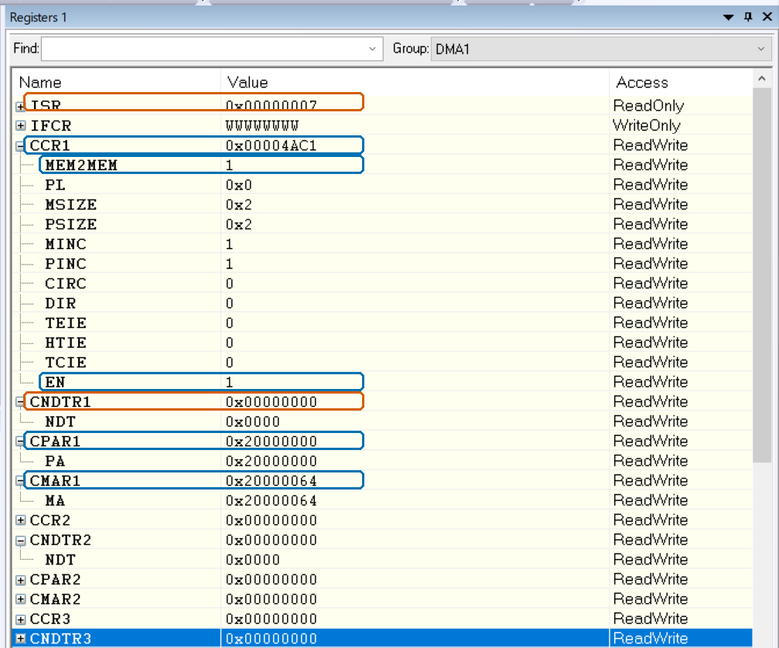
Figure 5. C-SPY Registers window — DMA1 channel 1 with every bit-field expanded; red boxes = live values (ISR with TCIF1=1, CNDTR1=0), blue boxes = fingerprint values (CCR1=0x4AC1 with MEM2MEM=1 and EN=1, CPAR1=0x20000000, CMAR1=0x20000064) — matching Tables 1 and 2 exactly

5.2 Memory verification
Table 3 — does g_dst equal g_src (Live Watch, hex):
idx | g_src | g_dst | idx | g_src | g_dst
[0] | 0x11111111 | 0x11111111 | [4] | 0x55555555 | 0x55555555
[1] | 0x22222222 | 0x22222222 | [5] | 0x66666666 | 0x66666666
[2] | 0x33333333 | 0x33333333 | [6] | 0x77777777 | 0x77777777
[3] | 0x44444444 | 0x44444444 | [7] | 0x88888888 | 0x88888888

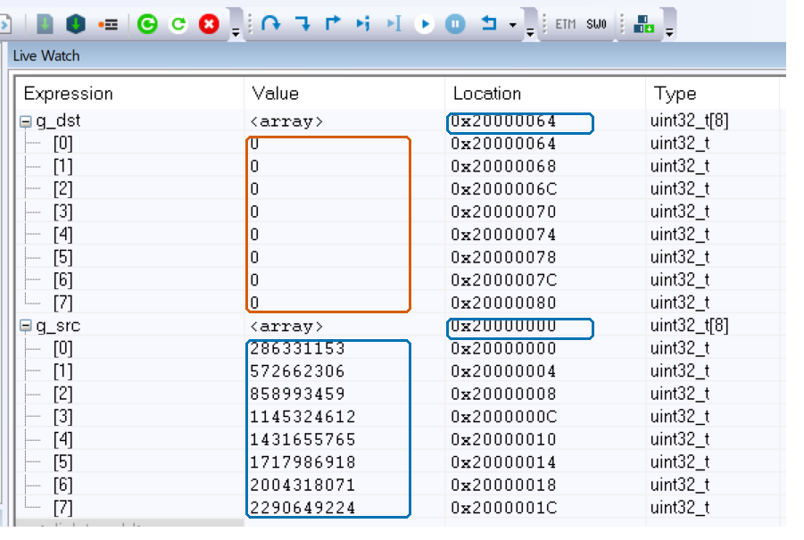
Figure 6. Before the run: g_dst[] all zeros (red box — about to change), g_src[] holds the pattern (blue box); the Location column (blue) already shows the fixed addresses 0x20000064 / 0x20000000
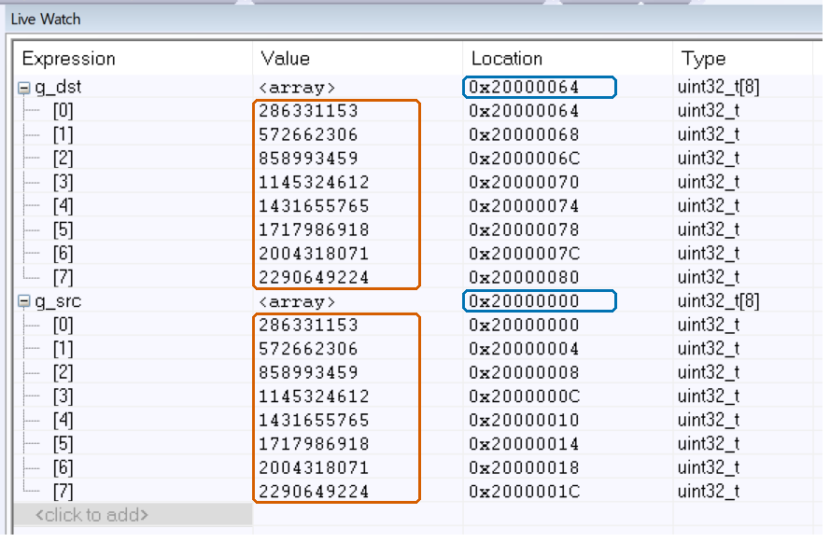
Figure 7. After the run: g_dst[] equals g_src[] — the DMA copy succeeded (red boxes on both value columns; IAR Live Watch displays decimal by default: 286331153 = 0x11111111)
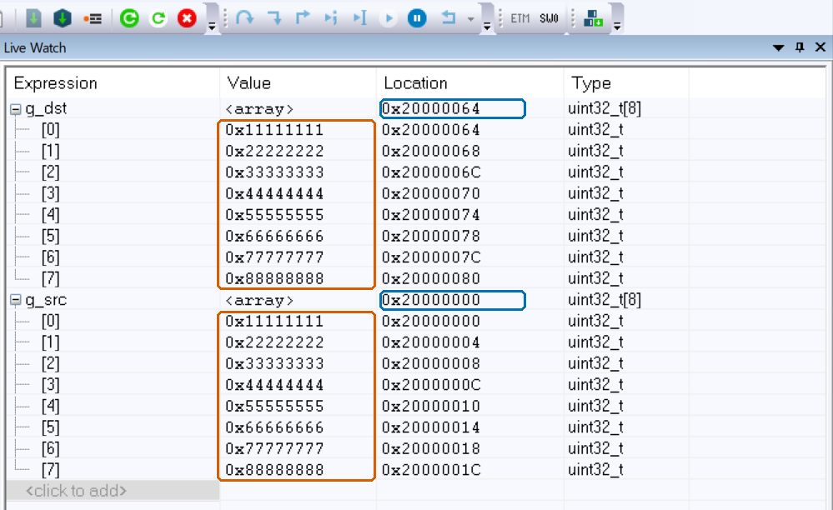
Figure 8. Same data with the display switched to hex (right-click → Format → Hexadecimal): g_dst[] == g_src[] = 0x11111111 … 0x88888888 — the pattern reads off directly instead of via decimal arithmetic

5.3 Evaluation against the objectives
Objective (section 3) | Verdict
Build 0 errors / 0 warnings | met (build #2)
g_dst == g_src after one run | met (Table 3)
TCIF1 = 1, CNDTR = 0 | met (Table 1)
No polling, no interrupts | met (TCIE/HTIE/TEIE = 0, empty while(1))
Minimal vendor footprint | met — 1/≈30 modules, 2/12 functions (section 5.4)
Evidence captured to logs/assets | met (Problem_A/logs/, Problem_A/assets/)
Fingerprint recorded for 0_2 / 0_3 | met (Tables 1–2 are the reference)

5.4 Vendor-API footprint
Problem A deliberately uses HAL at a minimum — an *ignition switch* to get on the air quickly, before rungs 0_2/0_3 verify everything down to the registers. At module level, 1 of ≈30 HAL driver files is compiled (~3%); at function level, 2 of the 12 public HAL_DMA_* functions are called (~17%).
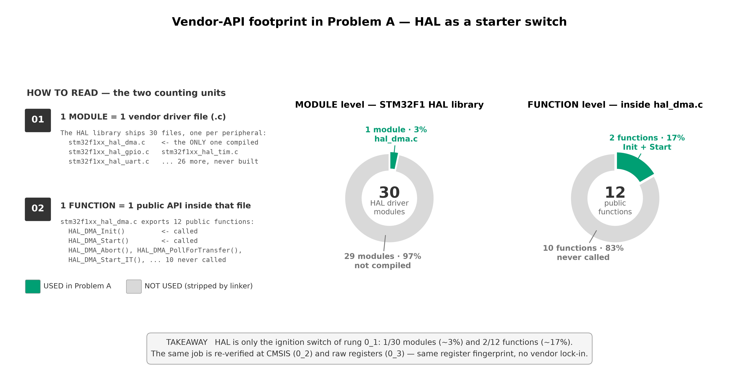
Figure 9. Vendor API usage in Problem A, with the two counting units defined by example: 1 module = 1 vendor driver file (only stm32f1xx_hal_dma.c of 30 is compiled, ~3%); 1 function = 1 public API inside that file (only HAL_DMA_Init + HAL_DMA_Start of 12 are called, ~17%); green = used, gray = stripped by the linker

5.5 Lessons learned
- mem2mem is too fast to watch `CNDTR` count down. The 8 words rip through at bus
speed (<1 µs) — every halt already shows CNDTR = 0. The proof it ran is
CNDTR=0 + TCIF1=1 + a full g_dst. A timer-paced transfer (Problem B) is where the countdown becomes visible.
- IAR Live Watch defaults to decimal (286331153 = 0x11111111); switch to hex via
right-click → Format → Hexadecimal.
- The Registers window must be refreshed (click a register) before it shows real values.
- The preprocessor's `#if` compares integers only — labels like 0_1 must be selected
with #ifdef, never #if == (fixed; recorded in bug_log).
- An IAR "configuration" lives in both `.ewp` and `.ewd`; creating a config is GUI
work (it touches device/linker settings); the shared source list is split per config with <excluded> flags.

6. References
- STMicroelectronics, *RM0008 — STM32F101xx/102xx/103xx/105xx/107xx Reference Manual*, ch. 13 "DMA controller" (register definitions: CCR, CNDTR, CPAR, CMAR, ISR/IFCR).
- STMicroelectronics, *STM32F103x8/B Datasheet* — local copy: docs/datasheets/stm32f10xxx.pdf.
- STMicroelectronics, *UM1850 — Description of STM32F1 HAL and low-layer drivers* (HAL_DMA API).
- Vendor driver source: stm32f1xx_hal_dma.c (STM32CubeF1 package, mirrored in this repository) — ground truth for the 12-function count of section 5.4.
- Project coding standard: STANDARD.md (register-map DSL used at rung 0_3).
- Captured on-board evidence: Buoi_12/Problem_A/logs/ (DMA1.log, LiveWatch-hexa.log, LiveWatch-binary.log, runtime_buoi12.log).
List of Figures

